TIBETAN LANGUAGE LEARNING PLATFORM
An Agentic AI Architecture
System Design & Technical Architecture Document
Instead of saying  "We built an AI tutor." | Frame it as  An Agentic Learning System where multiple specialized AI agents collaborate around a shared learner profile.

This document lays out the end-to-end architecture for a Tibetan-language learning platform built as a multi-agent system rather than a single chatbot wrapper. Specialized agents plan, correct, evaluate, and recommend — all reading from and writing to a shared learner profile, grounded in a retrieval-augmented knowledge base of Tibetan grammar, dictionaries, textbooks and exam papers.

1. High-Level System Architecture
The platform is organized into five layers: a React frontend, a FastAPI backend, a LangGraph-based agent orchestrator, a set of specialized agents, and a storage/RAG foundation. Requests flow top-down; learner data and retrieved knowledge flow back up into every agent's context.
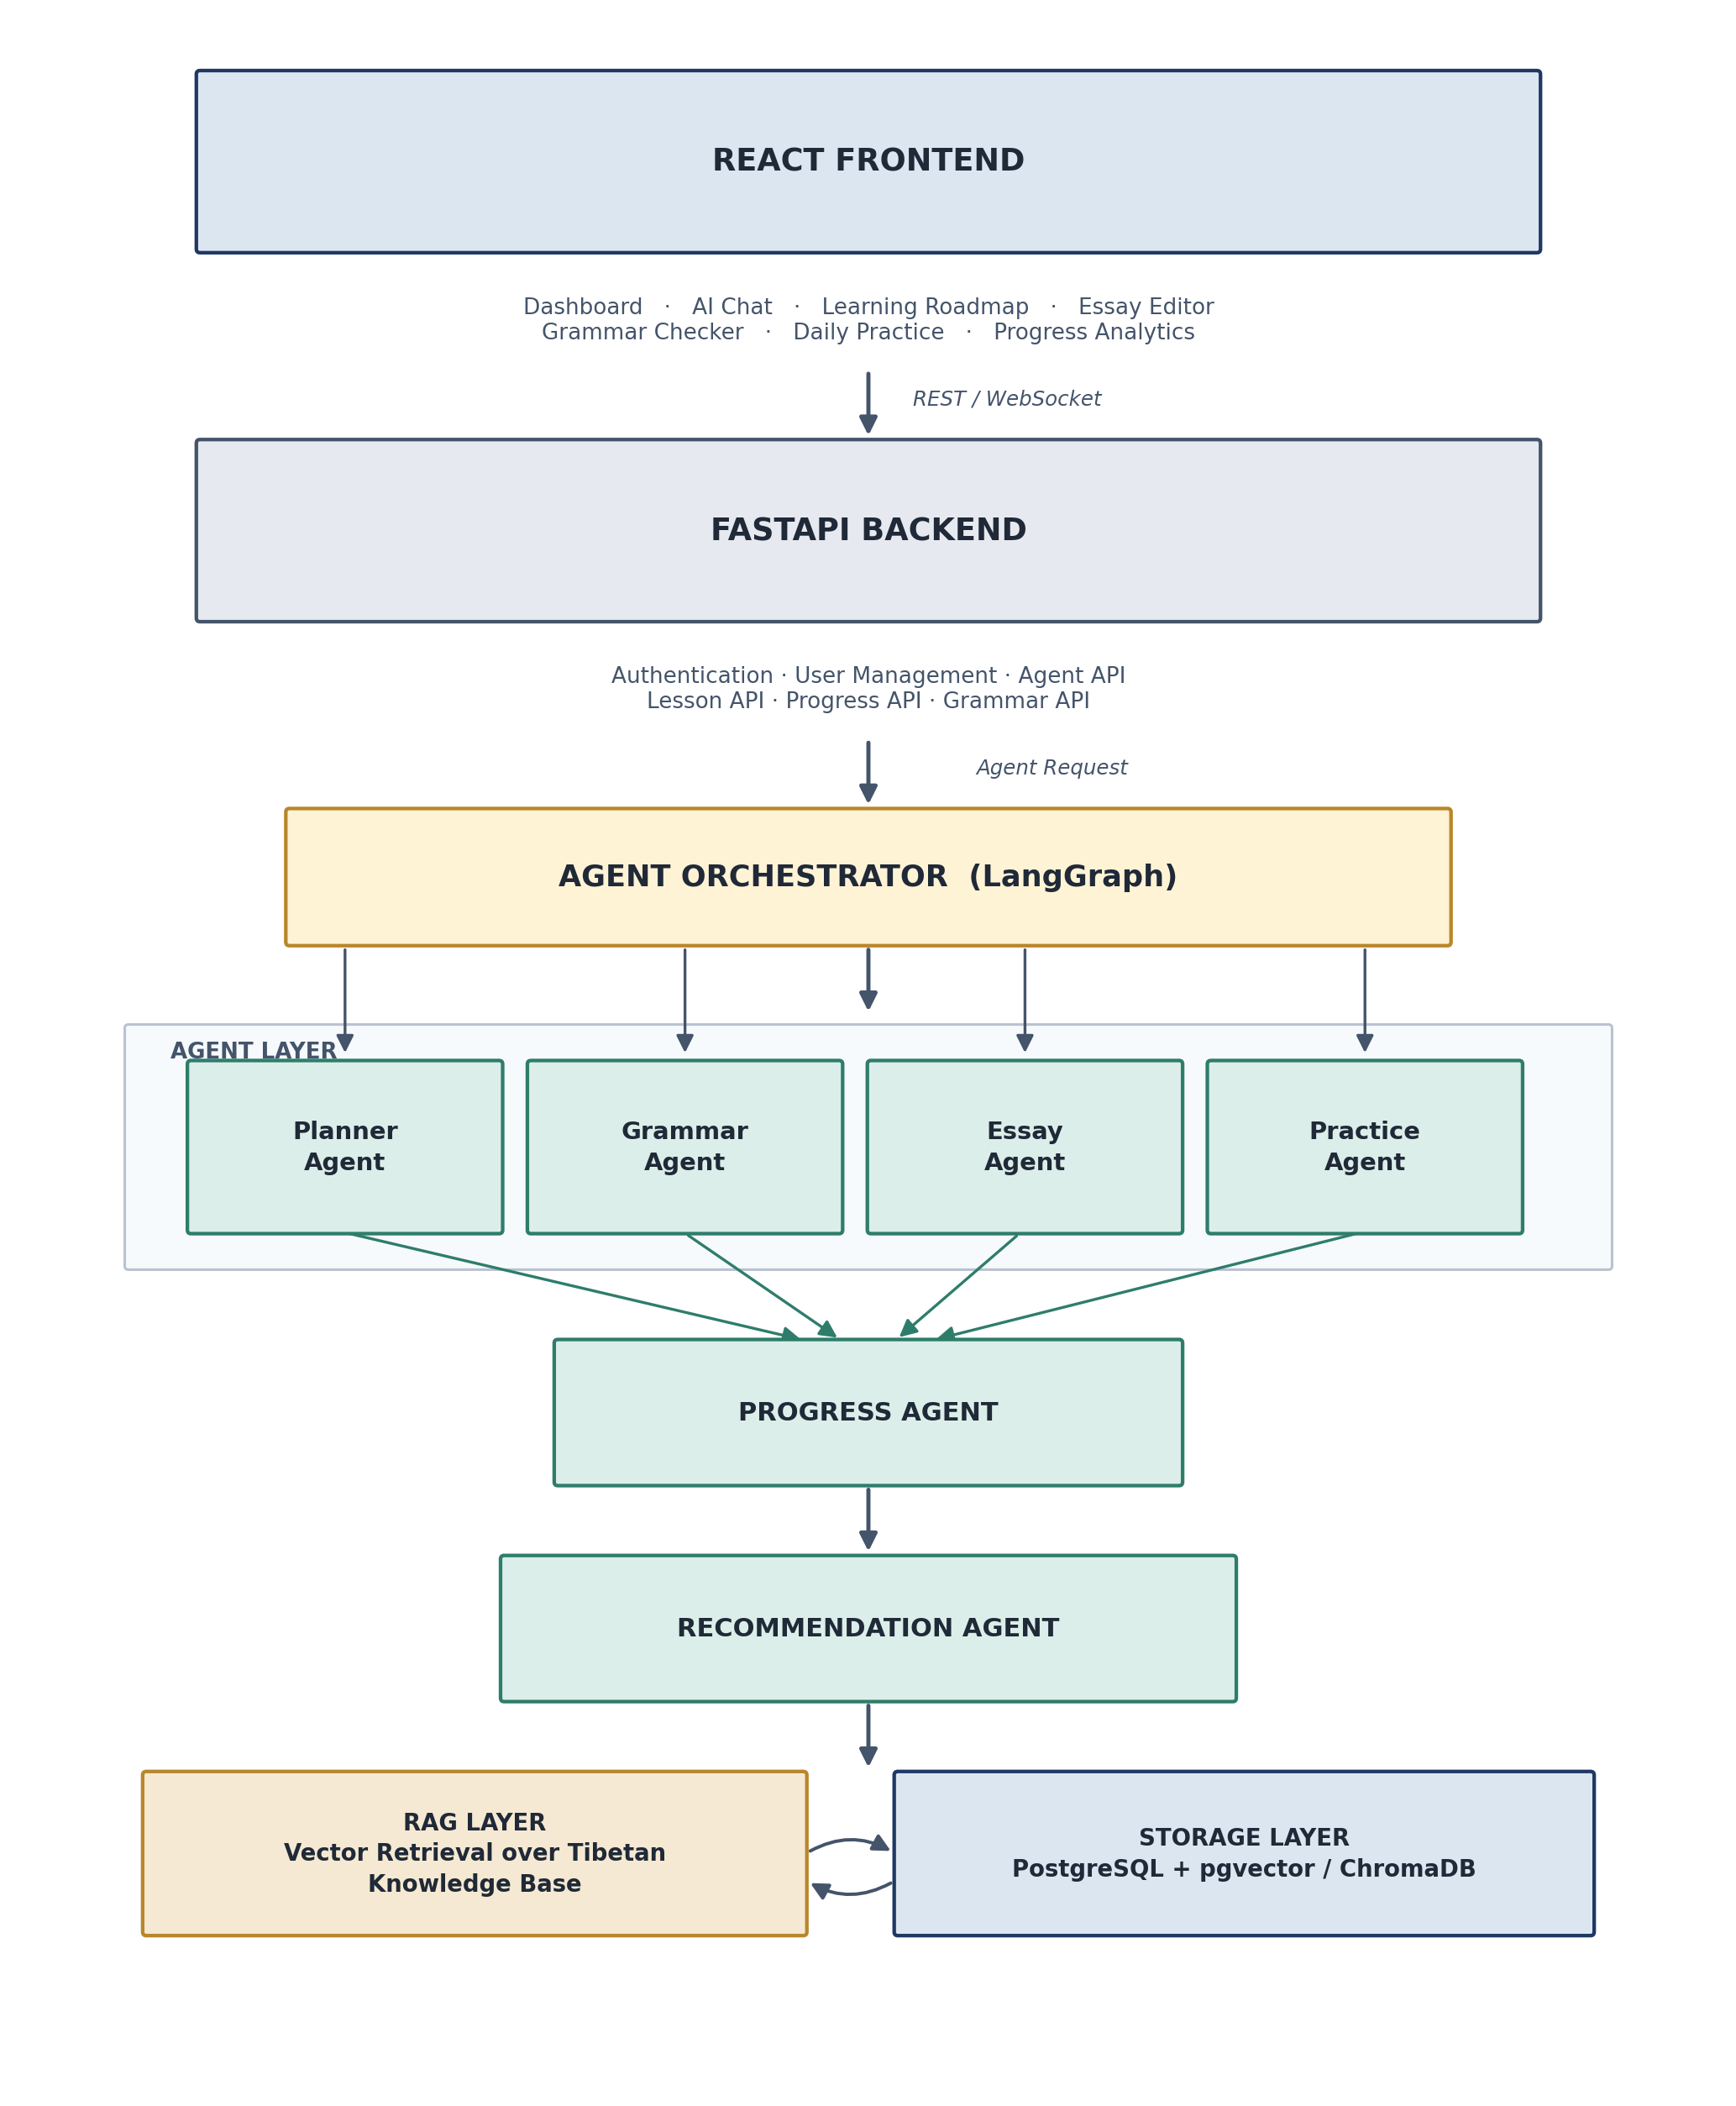
Figure 1 — High-level system architecture, from UI to storage.

2. Agentic Collaboration Model
Rather than a single LLM endpoint answering isolated prompts, six specialized agents collaborate around one persistent learner profile. Each agent has a narrow responsibility, a defined input/output contract, and reads shared context so its output improves the others' decisions.
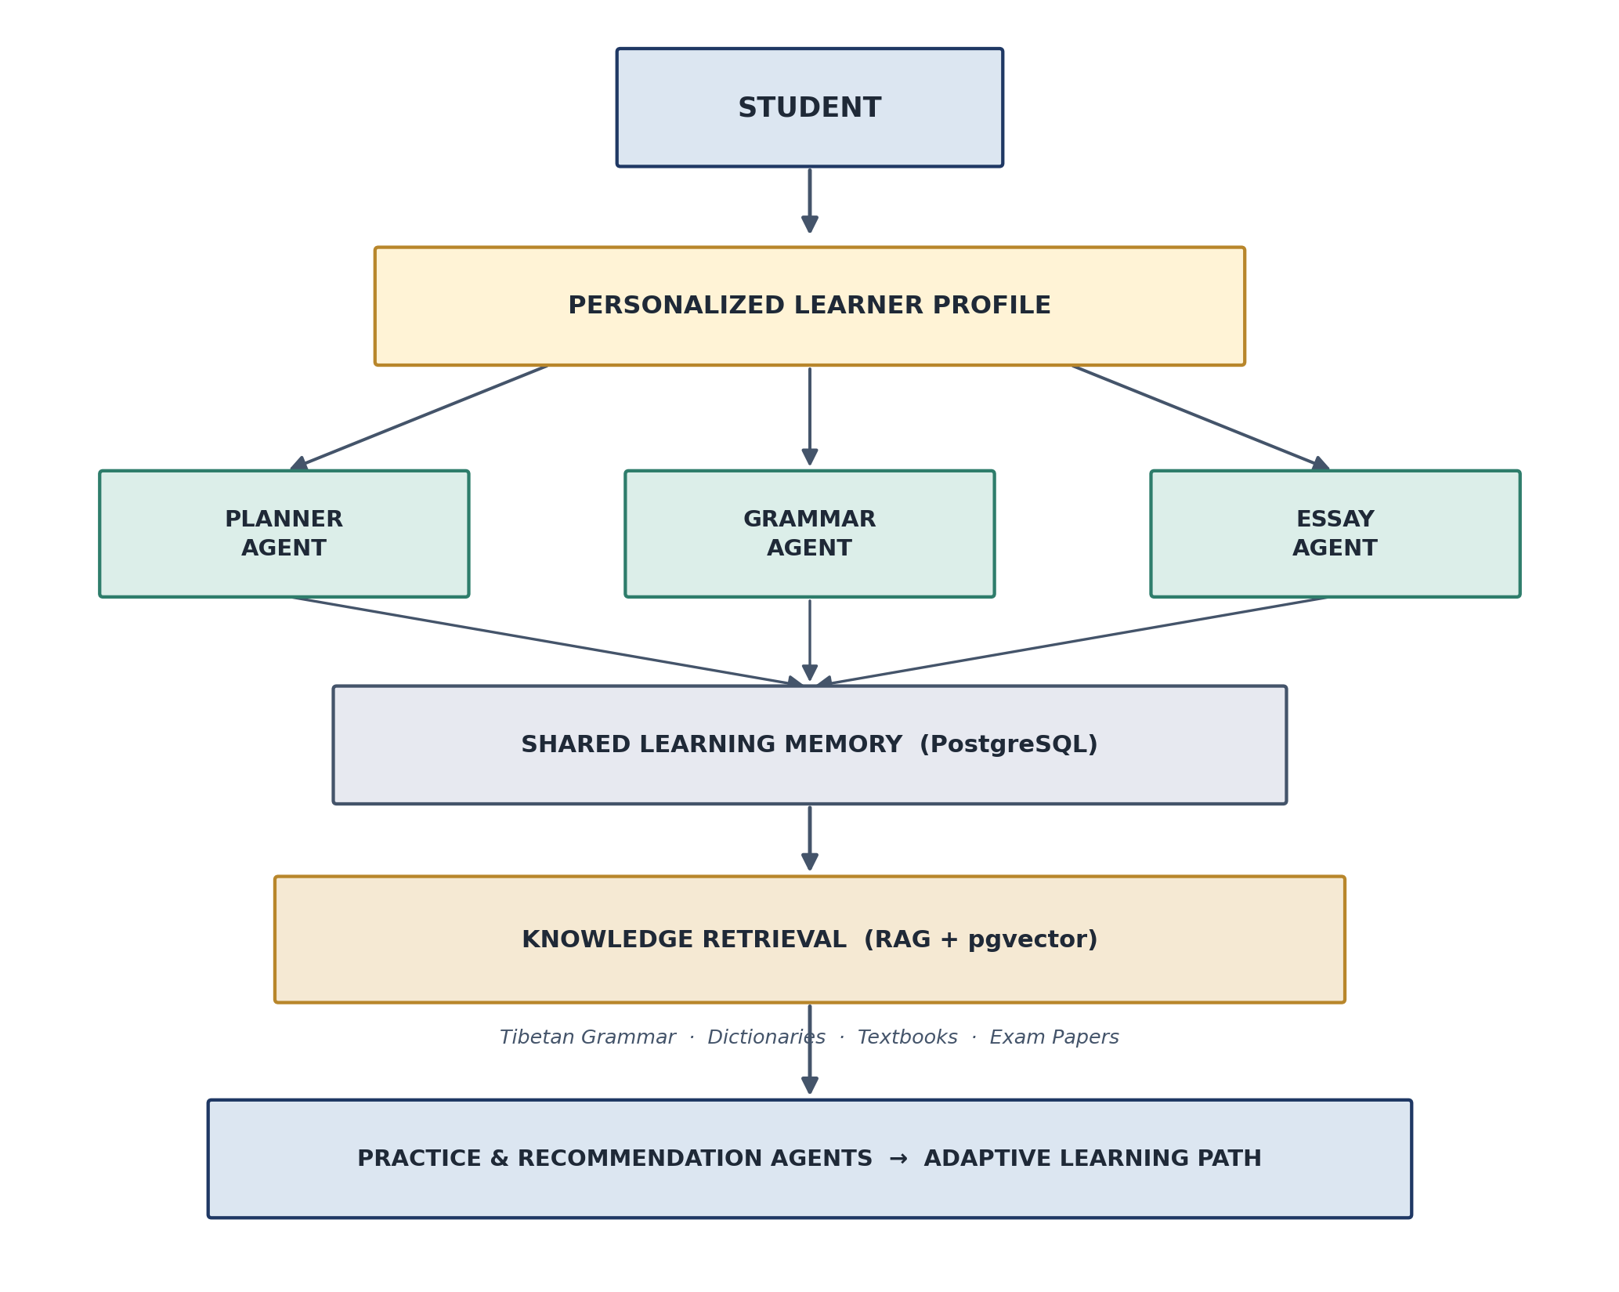
Figure 2 — Agents collaborating around a shared learner profile and memory.

2.1 Agent Responsibilities
Agent | Input | Output | Role in System
Planner Agent | Age, native language, current level, goal, daily study time, learning style | Personalized week-by-week roadmap (alphabet → grammar → speaking practice → ...) | Generates the initial and evolving learning path for each student
Grammar Agent | Student essay text | Grammar mistakes, honorific mistakes, explanations, corrected version, related rules, practice questions | Retrieval-augmented correction using grammar books, style guides and dictionaries
Essay Evaluation Agent | Full student essay | Grammar / vocabulary / fluency / naturalness scores, reading level, suggestions | Holistic scoring of writing quality across five dimensions
Daily Practice Agent | Yesterday's mistakes and progress data | Today's fully AI-generated exercises (no fixed curriculum) | Keeps practice adaptive and mistake-driven, day over day
Progress Agent | Grammar, writing, reading, speaking and vocabulary activity | Updated learning graph | Maintains the longitudinal skill graph that other agents read from
Recommendation Agent | Full learning history | Recommended stories, videos, readings and grammar lessons | Closes the loop by surfacing the next-best content

3. RAG Layer — Tibetan Knowledge Base
Every language-specific claim an agent makes — a grammar rule, an honorific correction, a vocabulary suggestion — is grounded in retrieval rather than model memory alone. Source material is chunked, embedded, and indexed so agents can cite the underlying rule or example.
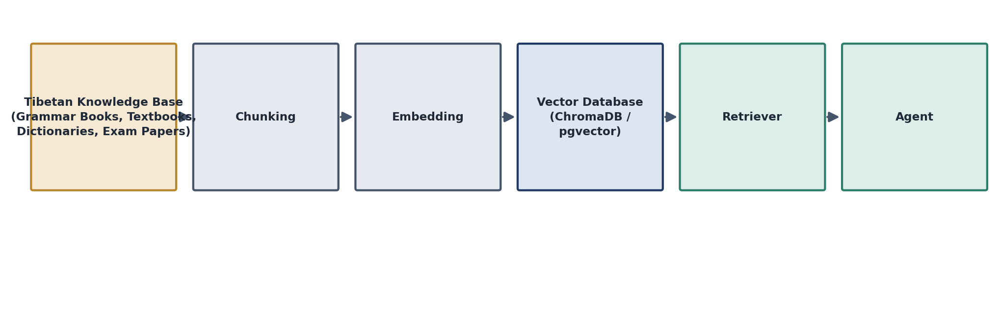
Figure 3 — Retrieval pipeline from raw source material to agent context.
- Grammar books and school textbooks
- Dictionaries and vocabulary lists
- Honorific rules
- Story books and reading materials
- Past exam papers
- Conversation examples

4. Storage Layer
Layer | Contents
PostgreSQL (relational) | Users · Learning Plans · Lessons · Progress · Vocabulary · Essays · Mistakes · Practice History · Achievements
Vector Database  (ChromaDB or PostgreSQL + pgvector) | Grammar chunks · Vocabulary · Examples · Lessons · Story embeddings

5. LLM Layer
Every agent — Planner, Grammar, Essay, Practice, and Recommendation — talks to the same LLM abstraction (services/llm.py), so the underlying model can be swapped or mixed per agent without touching agent logic.
- Qwen 3
- Llama 3
- GPT
- Claude
All accessed through one shared interface, allowing per-agent model selection based on cost, latency, or quality needs.

6. End-to-End AI Workflow
The student journey ties every agent together into a continuous loop: plan, study, correct, evaluate, track, recommend, practice, and re-plan.
Student Registers
-> Planner Agent generates the initial roadmap
-> Learning Roadmap
-> Student Studies
-> Grammar Agent corrects essays as they're written
-> Essay Agent scores overall writing quality
-> Progress Agent updates the learning graph
-> Recommendation Agent surfaces next-best content
-> Daily Practice Agent generates today's exercises
-> Updated Roadmap the loop continues

6.1 End-to-End Data Flow
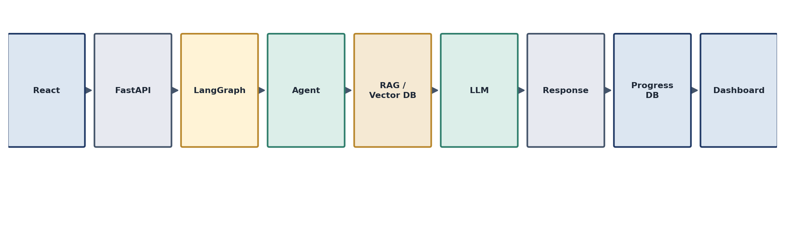
Figure 4 — A single request's path from the React client to a rendered response.

7. Project Structure

7.1 Backend (FastAPI + LangGraph)
backend/
└── app/
├── api/
│ ├── auth.py
│ ├── grammar.py
│ ├── essay.py
│ └── planner.py
├── agents/
│ ├── planner_agent.py
│ ├── grammar_agent.py
│ ├── essay_agent.py
│ ├── practice_agent.py
│ ├── progress_agent.py
│ └── recommendation_agent.py
├── graph/
│ └── workflow.py # LangGraph orchestration
├── rag/
│ ├── retriever.py
│ ├── embeddings.py
│ └── vector_store.py
├── services/
│ ├── llm.py
│ └── prompt_manager.py
├── models/
├── database/
└── main.py

7.2 Frontend (React)
src/
├── pages/
│ ├── Dashboard
│ ├── LearningPath
│ ├── Grammar
│ ├── Essay
│ ├── Practice
│ └── Progress
├── components/
│ ├── AIChat
│ ├── LessonCard
│ ├── GrammarResult
│ ├── Roadmap
│ └── ProgressChart
├── hooks/
├── api/
└── store/

8. Future AI Features
- Voice pronunciation evaluation
- AI reading companion
- Conversation practice agent
- AI memory that remembers every mistake
- Adaptive curriculum
- AI-generated quizzes
- AI-generated lesson plans
- Teacher dashboard

9. Recommended Framing for Judges
The technical story is stronger when the emphasis is placed on three properties of the system, rather than on any single feature:
- Collaboration between specialized agents around one shared learner profile, instead of one generic prompt handling every task.
- Persistent learner memory that every agent reads from and writes to, so corrections and recommendations compound over time.
- Adaptive, retrieval-grounded learning — no fixed curriculum; each day's content is generated from yesterday's mistakes and grounded in a real Tibetan knowledge base.
Together, these position the project as an agentic learning system rather than an AI tutor bolted onto static content — a materially stronger technical narrative for a judged setting.

